A1221-Eur-Cyprus-Horse-Terracotta-Cypro-Archaic II, 600-480 BCE

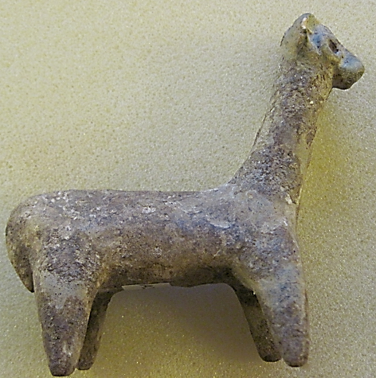 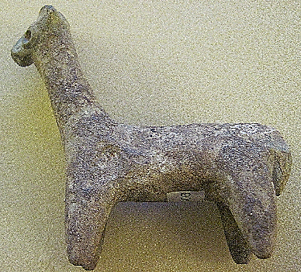

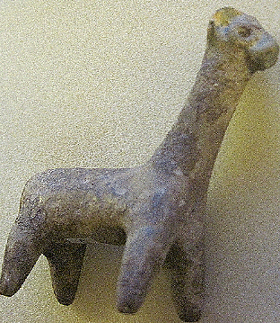 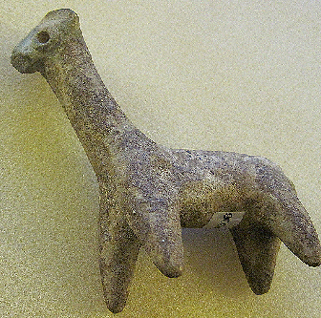

Figs. 1-4. Cyprus-Horse-Terracotta-Cypro-Archaic II, 600-480 BCE

**Case No.: 3**

**Accession Number: A306**

**Formal Label:** Cyprus-Horse-Terracotta-Cypro-Archaic II, 600-480 BCE

**Display Description:**

Archaic horse sculpture found near the temple of Hylates at Kourion, Cyprus. Hylates was a local god associated with the woods of the area (ὕλη, forest) and was thought to be like Apollo. His worship in the Archaic Sanctuary originally comprised an enclosure near the center of the later, much larger temple, extended from the 3rd century BCE until the 3rd century AD/CE so that this sculpture ante-dated the temple by about 200 years. This horse shows a large stylized eye, suggestive of the wild nature of the area in keeping with the later god Hylates’ own symbolic wild nature. This archaic horse has a small extended snout, a large maneless neck, and a small clubbed tail. This type of horse sculpture resembles one (with a rider) from the famous Cesnola Collection, although there is no evidence that this was part of that group.

**LC Classification:**  DS54.3

**Date or Time Horizon:** Cypro-Archaic II, 600-480 BCE

**Geographical Area:** From the temple of Apollo Hylates at Kourion, Cyprus

**Map,**

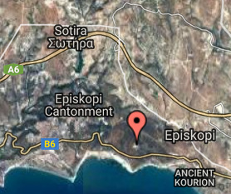 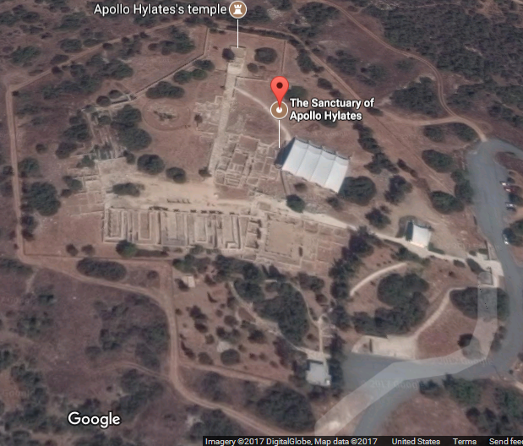

**Fig. 5. Map of the location of the Archaic Sanctuary of Hylates.** Map data ©2017 Google Imagery ©2017 TerraMetrics. Fig. 6. Map of the **Archaic Sanctuary of Hylates and its relationship to the Aopllo Hylates Temple.** Map data ©2017 Google Imagery

**GPS Coordinates:** 34º39'54.13" N 32º53'12.42" E

**Cultural Affiliation:** Cypro-Archaic II, 600-480 BCE

**Geographical Area:** sanctuary of Apollo Hylates at Kourion, Cyprus

**Medium:** Terracotta

**Dimensions**: H 91.87 mm, 3.616 in; L 101.04 mm, 3.978 in  
**Weight**: 84 g, 2 7/8 oz

**Provenance:** From the sanctuary of Apollo Hylates at Kourion, Cyprus(Cesnola 1894).

**Condition**: original

**Discussion:**

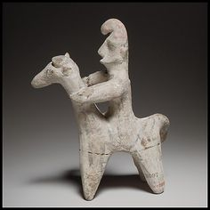A variety of horse sculptures from the Archaic Period lends interest to the symbolic and naturalistic aspects of the ceramists who worked these images.

Fig. 7. Terracotta horse and rider, ca. 750–600 B.C. Cypriot. The Metropolitan Museum of Art, New York. The Cesnola Collection, Purchased by subscription. From <https://i.pinimg.com/564x/62/ae/20/62ae20631853a8a0c2168fb3f71ddef7.jpg>

This example from the Cesnola Collection displays the extended neck and clubbed tail of the horse as on the present example.

**References:**

Doell, Johannes. 1873. *Die Sammlung Cesnola*. no. 934, p. 62, pl. XIV.21, St. Petersburg: L’Académie Impérial des Sciences.  
  
Cesnola, Luigi Palma di. 1894. *A Descriptive Atlas of the Cesnola Collection of Cypriote Antiquities in the Metropolitan Museum of Art, New York*, Vol. 2. pl. LXX.642, Boston: James R. Osgood and Company.

Karageorghis, Vassos, Gloria S. Merker, and Joan R. Mertens. 2016. The Cesnola Collection of Cypriot Art: Terracottas. New York: The Metropolitan Museum of Art.

Myres, John L. 1914. *Handbook of the Cesnola Collection of Antiquities from Cyprus*. no. 2097, p. 344, New York: The Metropolitan Museum of Art.  
  
McClees, Helen. 1920. "Greek Votive Offerings." *Bulletin of the Metropolitan Museum of Art*, 15(2): p. 37.  
  
Karageorghis, Vassos. 1995. *The Coroplastic Art of Ancient Cyprus*, Vol. 4. no. II(i)c.95, p. 91, pl. XLVIII.4, Nicosia: Foundation Anasatasios G. Leventis.